

Download Living Values Education Materials

Living Values Education is a ‘not-for-profit’ organisation providing 'download' materials free of cost. We are, however, very grateful to accept donations as an expression of gratitude.
- VbA – The Key to a Better Life
- Materials For Schools
- Materials For Living Green Values
- LVE Activity Booklet Values Library
- Materials For Businesses
- Materials For Distance Programmes

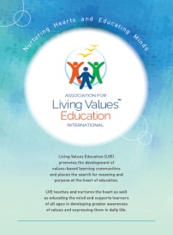
Distance Association for Living Values Education International Brochure – Read the ALIVE brochure and discover an overview of our organisation, its vision and aims, and how the Living Values Education Approach may be used in a wide variety of settings and ways including in schools, at home, and to support care for the environment.

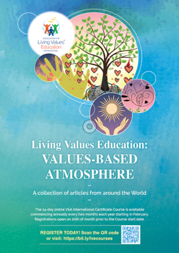
Value-based Atmosphere Book – Responses from the LVE international community have allowed us to publish this beautiful 52-page book dedicated solely to the LVE Approach and to the Values-based Atmosphere. (desktop or phone version).

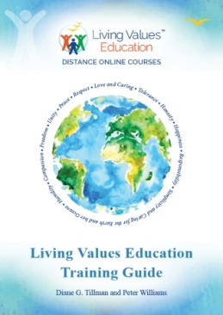
LVE Educator Training Guide* – The Training Guide delivers all the techniques and skills required to feel confident to facilitate activities and workshops using the Living Values Education materials with community groups, schools, families, etc. The Guide provides professional advice, recommendations as to how to be a successful facilitator. Learn about ALIVE, Living Values history, the resources available to you, and to benefit from http:// livingvalues.net website.
*Available from Amazon US$15

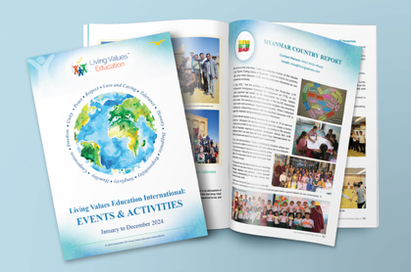
ALIVE International Activities and Events Book 2024 – We are proud to share your country reports which are a wonderful source of inspiration and upliftment and it is both refreshing and humbling to read of the efforts made, often in very challenging circumstances.
The level and nature of Living Values Education activities carried out vary considerably from country to country. In some countries, Living Values Education is being used and yielding good results in schools or other educational settings, formal, informal or non-formal, while in other places activities are limited to holding professional development workshops, and elsewhere it may be the case that additional support or resources are required before activities take root.
ALIVE would like to thank all the ALIVE Associates and the Focal Points for LVE who have contributed news of their recent activities. You can read more reports from countries with current Living Values Education activities on our website: https://livingvalues.net/country-reports/
- Download your Free copy here

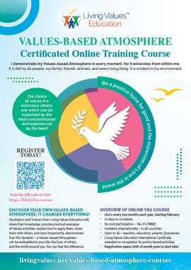
Living Values Education Values-based Atmosphere Certificated Online Training Course – Here, Facilitators and Trainers from Living Values Education will share their knowledge, provide practical examples of Values activities, explain how to apply them, share them with others, and most importantly, demonstrate how this dynamic – a Values-based Atmosphere – can be embedded in your life, the lives of others, and the world around you. You can feel the difference!
- Course start dates: 14 February / 14 April / 14 June / 14 August / 14 September / 14 December
- Each Online Course has 14 days to complete (a total of 8-10 hours)
- No limits on participant numbers
- Available internationally, in all countries
- Available to all: teachers, educators, parents, and business and community leaders, individually or collectively in groups defined by you.
- Living Values Education International Certificates are awarded on the completion of points-based activities
- Registrations open on the 20th of each month preceding each Course commencement
- Participation is FREE
- Click here to find out more
Download your FREE Brochure for information on the LVE Values-based Atmosphere Online Course and pass onto family, friends and colleagues: VbA Course Brochure (pdf, A4, 4 pages)

Materials for Schools
Designed to address the whole child/person, Living Values Education activities engage people of all ages in exploring, experiencing and expressing values so they can find those that resonant in their heart, and build the social and emotional skills, which enable them to live those values.
The universal values explored are of Peace, Respect, Love, Cooperation, Happiness, Honesty, Humility, Responsibility, Simplicity, Tolerance, Freedom, Unity and more.
The initial set of five books known as the Living Values Education series are:
- Living Values Education Activities for Children Ages 3–7
- Living Values Education Activities for Children Ages 8–14
- Living Values Education Activities for Young Adults
- Living Values Education Parent Groups: A Facilitator Guide
- LVE Educator Training Guide

These Books (above) are all Available from Amazon – each US$15

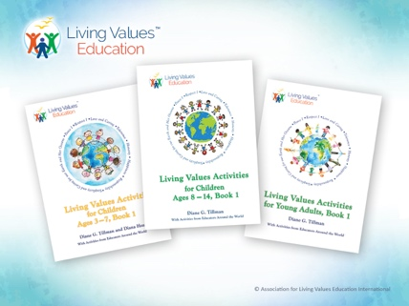
LVE Rainbow Booklet Series – for download:
Values Activities for Children Ages 3-7, 8-14 and Young Adults
Recognising the many challenges faced by teachers today with all ages of young people we created a Library of Values Activity booklets which are essentially ‘classroom aids’ providing ideas, using activities to assist in dealing with specific classroom issues, capturing student imagination, participation and discussion, perhaps bringing our young people to a different, more caring and responsible space.
Each value activities booklet of approx. 40-56 pages is easily printed on school printer as A5 booklet/pocket book size, landscape, 2 up, colour cover and b/w inside. Alternatively, you could download the files and order your choice of booklets from your local photocopy shop (one colour) for about $3 each.
Download LVE Activity Booklets Library Overview – For Ages 3-7, 8-14, Young Adults
Introduction and Overview, Part B: Appendix, Unit 1: Peace, Unit 2: Respect, Unit 3: Love and Caring, Unit 4: Tolerance, Unit 5: Honesty, Unit 6: Happiness, Unit 7: Responsibility, Unit 8: Simplicity and Caring for the Earth and her Oceans.

- Classroom & Workshop Support Materials
- Download FREE Songs in mp3 format.
- Download FREE Stories. The stories were chosen because of their relevance to a particular value. Each pdf file states the values unit and lesson in which the story is included; the name of the story and author are stated in the relevant lesson of the book.
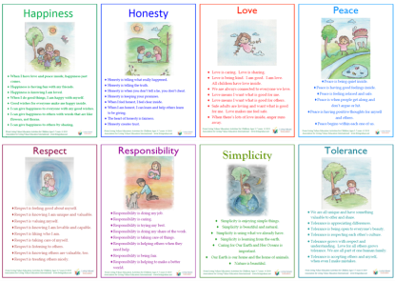
Posters for Children and Young People
Living Values Education posters are Reflection Points for each value. They are offered to assist and remind students and others seeking values awareness the various qualities of each value. For hand-outs can be printed as an A4 page in colour and also be increased in size to A3 (bigger) for display posters in the classroom. Available in Word or as a pdf file.
Download Posters: The .docx versions allow for language translation.
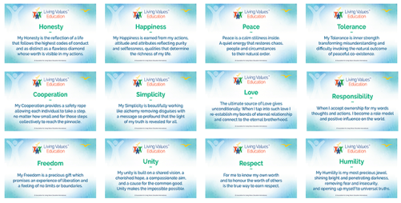

Living Values Education Values Cards
The simple values cards (setup as six per A4 page) are used as reminders for what the values offer to us and we offer to the values. Ideal for printing off and using one value each day for a week to remind ourselves of the treasure they can bring to our lives. The values cards are ideal for creating a point of focus in group situations, passing around and sharing with one another about what the particular value means to us, thus opening the doors for mutual discussion and self-discovery.
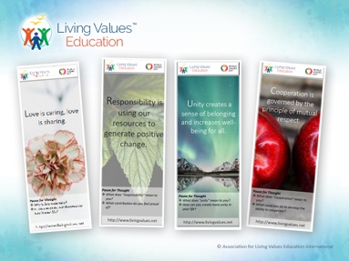
LVE Bookmarks
Living Values Education offers a set of 12 bookmarks to be used in a multitude of ways; for daily reflection, questions to ask ourselves, a gift for practical use, even to use expanded for display as Values posters in the home or classroom.

Living Green Values, Activities for Children and Young Adults
These Living Green Values activities are intended to help young people be more aware of the importance of taking care of the Earth and her resources. Part of that process is awakening love for nature and her creatures and learning about specific ways that they can help be a friend to the Earth.

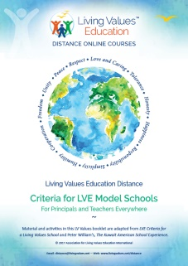
LVE Booklet Library
eBooks download for reading online or self-print option and copying. Provide Activities for Everyone – Teachers, Care Givers, Parents, Individuals, Special Interest Areas, Living Values for Self and Community Development. Information and requirements for becoming a LVE based school.
Living Values Education The Living Values School Experience
Living Values Education Criteria For LVE Model Schools
Living Values Education Improving Facilitation Skills

Materials for Businesses
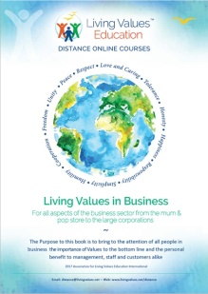
- Living Values in Business – For Associates, Focal Points and Facilitators
This 52-page book is to bring to the attention of LVE facilitators the opportunity of assisting business of all types and size to the importance of values in business, to provide support information and how the material can be used.
- Living Values in Business – For Owners / Managers/ Employees
Of all the Values one would assume are important in the business environment perhaps the Value of Happiness would not be the first that comes to mind, yet as the booklet demonstrates the Values-based Atmosphere is intrinsic to the wellbeing of very organisation from the mom and pop corner grocery store to the large corporate environment.
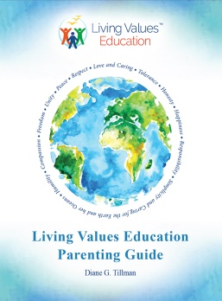
LVE Parenting Guide
LVE Parenting Guide - Suggestions and activities are shared to help parents help children, from toddlers to teens, use values to handle their challenges as well as to deal with the concerns of bullying and social media. Chapters are offered on balanced family life in regards to screen time, preventing sexual abuse and drug use, rebuilding relationships that appear broken and taking care of yourself are also included.

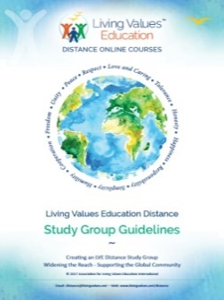
Materials for LVE Distance Programmes
- Living Values Education Distance - Values Activities
- Living Values Education Distance - Study Groups
- Living Values Education Distance - Facilitator Training
- Living Values Education Distance - Self-Reflection

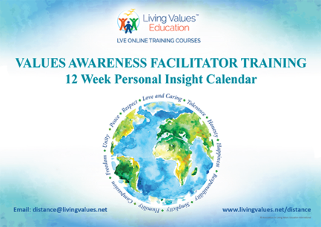
VAFT 12 Week Personal Insight Calendar
A Daily Values Reminder Calendar aligned to the VAFT 12 week schedule. This is part of the LVE VAFT Self-Reflection program, structured over 12 weeks, with daily contemplation of each value's qualities and how they appear in your life. You can use this as a great reminder for a daily reflection, or simply brighten up your experience – consider the message and questions to ask ourselves. This calendar is a 25 page pdf file, and can easily be printed on a school printer at A4 size. Whether it be in the home or classroom, everyone should have one on their wall!
Download FREE 12 Week Personal Insight Calendar (pdf version)

Stay in touch with Living Values Education Social Media
Our facebook and instagram pages provide an opportunity for followers to see our daily Living Values messages, and also join our weekly Living Values Self Reflection – a Values personal self-development activity – a 12 week program that you can join in at anytime.
Our social media also keeps you up to date with current events, such as our upcoming zoom meetings, and online course registrations and starting dates. Please note: these pages are monitored by volunteers, so direct messages may not be answered immediately. For any questions, contact distance@livingvalues.net.
Follow your country on Facebook:
Living Values Education
Living Values Education - USA
Living Values Education - Latin América
Living Values Education - Canada
Living Values Education - Australia
Living Values Education - New Zealand
Living Values Education - Philippines
Living Values Education - India
Living Values Education - Sri Lanka
Living Values Education - South Africa
Living Values Education - Nigeria
Living Values Education - Sierra Leone
Living Values Education - EU - English
Living Values Education - Netherlands
Follow us on Instagram:
@Living_Values_Education
@living.values.education_india

Living Values Education recognises that it is not practical for much of the world’s population to attend workshops and participate in organised Living Values Education activities due to cost, time, and travel requirements. Through this Distance opportunity, the Association for Living Values Education International Learning Center – ITC encourages and offers online courses to educators, individuals, families, and communities.
The Online resources in this section allow you to engage in activities directly yourself, among your family, friends, and colleagues, or even students in the classroom or workplace.
The materials for Living Values Education Distance include:
- Distance Facilitator Training – Join LVE as a facilitator – 12 week Certificated Course
- Distance Values Activities for Groups and Individuals – For Adults, Families, and Groups – a colourful 52-page Rainbow Booklet – participation book of activities, drawn from Living Values Education for Young Adults.
- Distance Personal Journal – a 97-page book will help you record each of the activities and give you something to look back on.
- Values-based Atmosphere Book desktop & download version or phone version – what a Values-based Atmosphere means for educators and how it can be yours.
- Audio-Guided Meditations – Five meditations bring you closer to Values Awareness.
- Distance Self-Reflection – Your 12 Week Values Personal Development booklet
- Distance Study Group Guidelines – A guide for Study Group hosts on 'how to' manage effective group activities.

Find all FREE Download options at: www.livingvalues.net/resources

